**Session 2 :**

**Random variables**: numbers used to represent possible outcomes of an uncertain event.

The probability distribution of a discrete random variable X must satisfy the following two conditions.

* P(x)≥0 for all possible values x of a random variable X
* 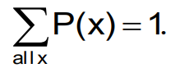

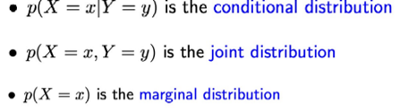Ex:

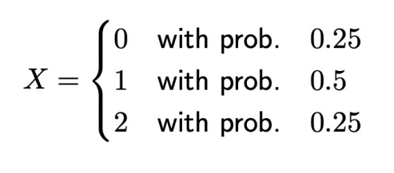

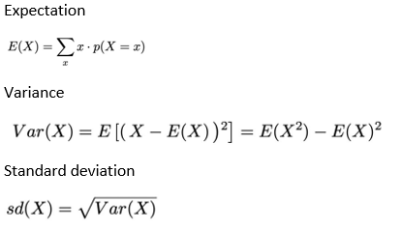PDF:

CDF:

Two random variables are independent If :



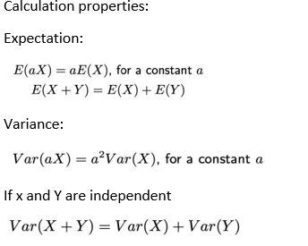

Covariance and correlation

**Covariance:**





**Correlation:**

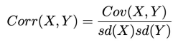



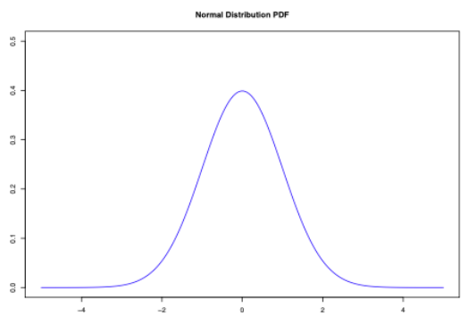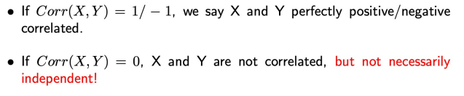

Normal distributions:



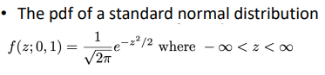

The PDF:

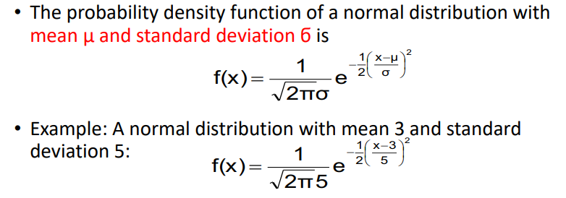

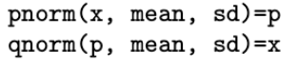

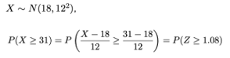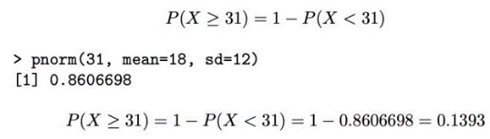

**Session 3 :**

**Bayes Theorem :**

